Designing and Building Software with Visual Studio and C#

Project 2 –Create a new Windows Forms application

November 7, 2018

Notes

1. Windows Forms is an Input/Output Platform for Windows applications. While Windows Forms is a relatively old such platform, it is still quite useful and is easy to learn at the introductory level. That's why we use it in these tutorials.
2. Create a new windows forms application
   1. Start Visual Studio
   2. Click the "Create new project…" link on the bottom center of the start page. The New Project dialog will appear.
   3. On the left select Windows Classic Desktop under Visual C#  
      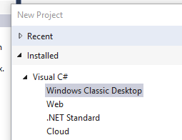
   4. In the center select "Windows Forms App (.NET Framework) Visual C#"  
      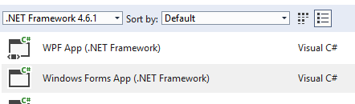
   5. In the Name text box in the bottom section of the New Project form, type HelloWorld. Notice that this also changes the name of the Solution to HelloWorld.   
      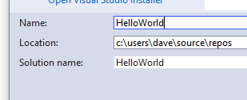
   6. Ensure that the Create directory for solution check box is checked:  
      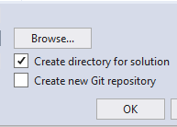
   7. The location box will be populated with the default location for your projects. You can change this if you wish. Leaving it alone for now is best.
   8. Click OK. The result will be something like this:  
      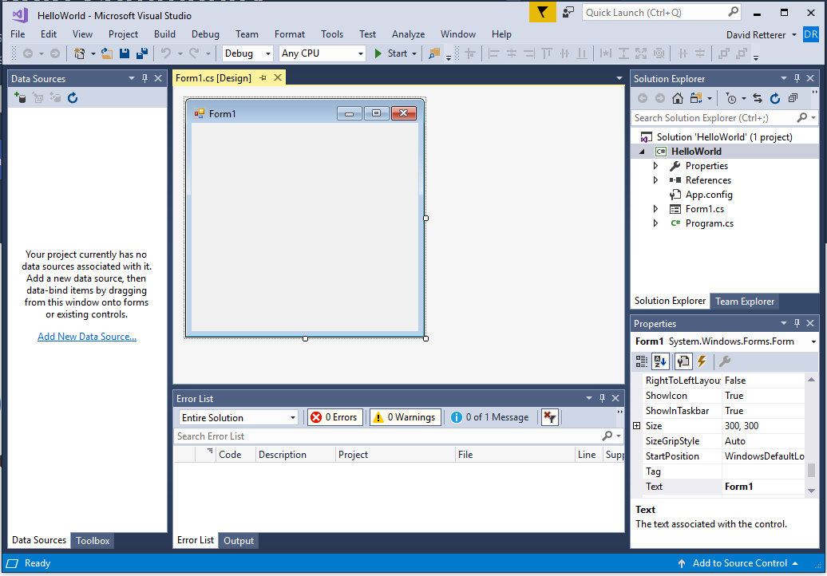

Click on the start button in the center of the main toolbar at the top. You should see a Windows form pop up somewhere on the screen. This is a fully functional, but a do nothing windows application. We are going to fix that.  
